ATTITUDE DETERMINATION AND CONTROL SUBSYTEM

CONCEPTUAL DESIGN REP0RT

PREPARED BY:
ASTHA GARG
ATUL FOTEDAR
DEEPIKA GOEL
DHRUV MALHOTRA
LAVINA KHANDELWAL
MILANPREET KAUR
NEHA WADHWA
UJJWAL GOEL

CONTENTS

- Introduction
1.1 Main Objectives
1.2 Requirements from other sub systems

- Theory and Background
2.1 Atmospherical Disturbances
2.2 Satellite Operation Modes
2.3 Reference System
2.4 Attitude Determination

- Components of ADCS
3.1 Sensors
3.2 Control Algorithms
3.3.Actuators

- Magnetometer Analysis
4.1 Selection Process
4.2 General Description

- Sun Sensors
5.1 Operation
5.2 Design
5.3 Testing System

- Control Algorithms
6.1 Kalman Filter
6.2 Detumbling Controller
6.3 Albedo Correction Algorithm
6.4 Reference models

- Actuators
7.2 Magnetic Torquers
7.3 Analysis of torquers
7.4 Materials for coil
7.5 H Bridge circuit
7.6 Designing

INTRODUCTION
The main purpose of this report is to present the development of the Attitude Determination and Control System (ADCS) for TUSSAT. The ADCS must determine the position, velocity and orientation and also control the satellite. The determination is the most important point, because we must know where the payload is pointing to. The major concern of the control is to reduce the spinning rate of the satellite after the launch.

1.1 Main objectives
• For the measurement and control of the motion of the satellite once it is in orbit.
• For providing the necessary pointing accuracy to the antennae during Communication mode.
• For Power system requirements - facing the solar panels towards the sun to achieve maximum power generation.
• For Payload requirements - Eg. Focusing the satellite camera to a particular location on earth.

1.2 Requirements from various subsystems:

- Power requirements:
To drive various components of ADCS.

- Structures:
Ensure proper mounting and placement of ADCS components.

- OBC:
Software for various control algorithms.

2. THEORY AND BACKGROUND

2.1 Atmospheric disturbances

During the total life time the satellite is subjected to variable disturbances resulting from the various properties of the low earth orbit (LEO) environment.

• Aerodynamic Drag:
This disturbance is far less significant in low earth orbits than at ground level, but can nevertheless not be neglected at the orbit of the TUSSAT. There is no continuous air flow at these altitudes and torque experienced is due to movement of free molecules in all directions.
The aerodynamic force depends on the atmospheric density ρ, the drag coefficient, on the satellite surface area of the satellite and the velocity of the satellite.
T_{a} = torque due to atmospheric drag on the satellite
C_{pa}= Center of aerodynamic pressure
C_{g}=Center of gravity.
F_{a} = Aerodynamic drag vector in body coordinates
C_{d} = Aerodynamic drag coefficient
ρ = Atmospheric density
V = orbital velocity
A = Frontal projected area
Taking assumptions about the dimensions of the satellite:
The center of aerodynamic pressure can be approximated to the center of the cube, and the maximum distance between C_{pa} and C_{G} is 2cm then, because the center of the mass of the system should not be farther away than 2 cm from geocentric center. The atmospheric density at 400 km is around 10⁻¹¹ kg/m³. The velocity is roughly 7 km/s. The maximum surface area is A_{s} = .09 m². With all these quantities, the maximum torque provided by the aerodynamic drag is

T_{a}<1.039*10⁻⁶ Nm

This is the maximum amount of torque due to atmospheric drag the TUSSAT is going to experience as per our calculations.

- Residual Magnetic Torque:
Residual Magnetic Torque results due to the interaction of Earth’s magnetic field with the small magnetic fields created by the electronic components of the satellite. This residual dipole can be limited by placing the circuit wires properly and making them as short as possible.
T = D X B
D = Satellite’s residual dipole moment (A-m²)
B = Earth magnetic field vector (T)
T=D x (2M/R³)
Where M is the Earth’s Magnetic Moment
R is the earth’s Radius=6978 km (assuming altitude=600 Km)
(M is the magnetic moment of earth=7.96*10¹⁵ T.m³)

Calculating this quantity we get a limiting factor, that limits the amount of residual dipole moment that TUSSAT can have, given by:-

T_{rd}<46.854D,

Where T_{rd} is the torque due to the residual dipole moment.

- Solar Pressure Torque:
The pressure and the torque generated by the radiation emitted by the sun. The radiation force depends on the solar constant, reflectance factor, and the angle of incidence and area on which the sun is being exposed. The torque is found out by multiplying the force with the distance from the center of gravity.

Where Cps and Cg is the vector from the point of application of radiation to the point of the centre of gravity, where the torque is being applied.

F_{rad} = radiation force
A_{s} = Area exposed to the radiation of the sun
q = Reflectance factor that varies from 0 to 1, depending on the surface material which is facing the radiation.
α= the angle of incidence of the sun’ radiation.
F_{s} = Solar constant.
The mathematical treatment of these depends on the structure and is thus still pending.

- Gravity Gradient Torque:
Gravity Gradient torque is due to the non-uniform distribution of mass in the satellite. The heavier side of the satellite experiences greater weight force than the lighter side thus generating a torque about the center of mass which remains in dynamic equilibrium.
Gravity-gradient is used to stabilize some types of satellites with constant orientation with regard to Earth. In order to use these gravity forces, these satellites have asymmetric mass repartition (the moment of inertia along one axis is larger than along any other) so that one axis naturally points down towards Earth. The gravity-gradient torque can be calculated by:
Where μ is the earth’s gravity constant.

The mathematical treatment of these forces will be done after we are known about the mass distribution of various components inside the satellite.

  - Satellite Operation Modes

Initialization mode:
- After deployment satellite rotates at high angular rates
- Power supply unit turns the power on.
- OBC gets booted up.
- Sensors and actuators in ADCS are initialized.
- Hardware is tested and errors from initialization of ADCS hardware are reported.

De-tumbling Mode:
- Control algorithms calculate the signals that need to be generated and given to the coil driver in order to de-tumble the satellite.
- All available power is directed towards the actuator system.
- If completed successfully or no detumbling is needed, the system will continue to the next mode.

Communication mode:
- The computer control is passed back to the communication team.
- In this mode, ADCS is responsible to keep the satellite nadir pointing so that the antennae can point directly to the ground station.
- Power consumed in this stage is less than the de-tumble mode.
- Communication mode is active only when the satellite is within the range of ground station.

Power save Mode:
- Satellite’s attitude is changed so that solar panels are pointed towards the Sun. This is to obtain a maximum power input from the solar panels.
- When the satellite is in the shadow of the Earth (eclipse), it is important that power consumption is kept low in all subsystems.
- In this mode we make an attempt for the extra power generated to be greater than the power consumed by ADCS.
- Most of the times ADCS remains in power safe mode.

Emergency Mode:
- ADCS operations are kept to the minimal.
- Power to the actuators is kept off
- Sensors receive either low or no power depending on battery status.
- This mode is functional during high radiation winds and solar flares.

2.3 Reference System

The three critical parameters are rotations in three dimensions around the satellite’s coordinate system origin, the centre of mass. These angles are pitch, roll and yaw.

Pitch: rotation around the lateral or transverse axis.
Roll: rotation around longitudinal axis.
Yaw: rotation about the vertical axis.

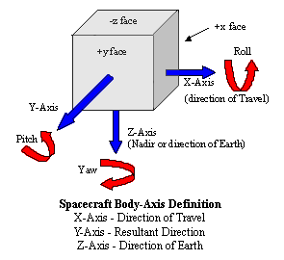

Coordinate Frames
For the purpose of determining the attitude in a three dimensional space, several coordinate frames are defined.

- Reference Coordinate Systems
To define an orbit around Earth, there are two specific Earth related coordinate systems. They both have their origin in the geometrical center of Earth and are named the Earth Centered Inertial (ECI) coordinate frame and the Earth Centered Earth Fixed (ECEF) coordinate frame.

The ECI Coordinate Frame: The term ECI stands for Earth Centered Inertial and represents a coordinate system with origin in the center of Earth, which is fixed relative to the Earth rotation. Its X-axis is parallel with the Vernal Equinox (The axis around which the Earth rotational axis is tilted relative to its orbital plane) and it’s Z-axis, which is parallel with the Earth rotational axis.

ECI Frame:
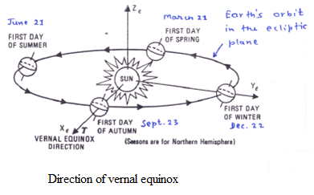

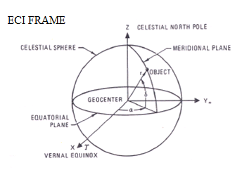

The ECEF Coordinate Frame: The second coordinate frame is the Earth Centered Earth Fixed (ECEF) coordinate frame. In this frame the X-axis is passing through the zero longitude, also known as Greenwich meridian, and has a Z-axis parallel with the rotational axis. In this way the ECEF frame is fixed to the earth itself and rotates around with it.
- Satellite Coordinate Systems
To determine the attitude of the satellite, some satellite fixed coordinate systems are introduced. The attitude and position of the satellite is accordingly given as a rotation between the satellites fixed coordinate frames and the reference frames.

The Satellite Body Frame Conventional sequence of rotations from inertial frame to body frame of reference:
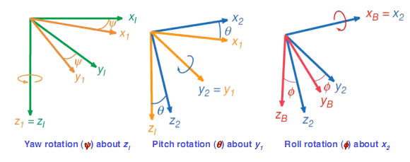
- Each rotation is about a single axis
- Using right-hand rule
- The sequence of rotation is yaw, pitch, roll
Body Frame, is placed in the center of mass of the satellite and fixed to the satellites geometric axes.

The Satellite Orbit frame: The Satellite Orbit frame, is the link between the satellites fixed frames and the reference frames. It is parallel with the ECI frame axes but centered in the satellites center of mass. This frame is used to transfer the vectors calculated with reference to the earth centered coordinate systems out to the satellites position to compare them with the measurements of the attitude determination in the SCB frame.

  - Attitude Determination

EULER ANGELS:
Euler angels measure the orientation of one frame with respect to another frame.

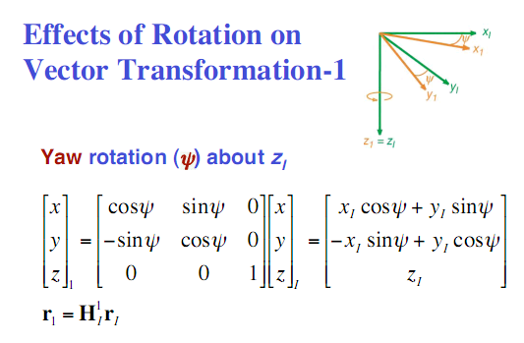

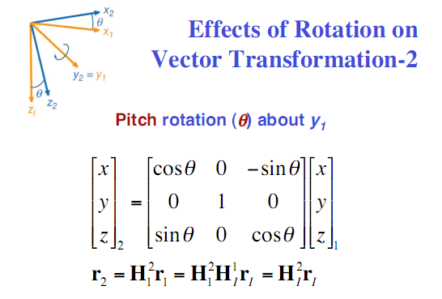

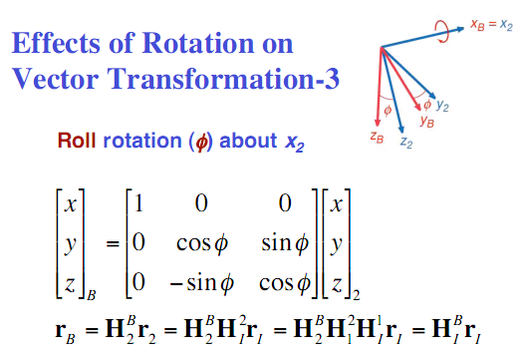

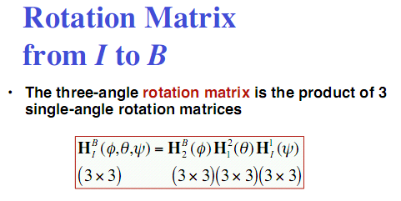

ATTITUDE DETERMINATION USING TWO VECTOR MEASUREMENTS
TRIAD
The two vectors are typically the unit vector to the Sun and the Earth’s magnetic field vector for coarse “sun-mag” attitude determination. We use the Triad algorithm for this.
We have measured two unit vectors and in the spacecraft body frame. These can be the unit vectors to some ambient vector field such as the Earth’s magnetic field. We consider only unit vectors because the length of the vector has no information relevant to attitude determination. Each of these unit vectors thus contains two independent scalar pieces of attitude information. The spacecraft attitude is represented by a 3×3 orthogonal matrix A.
It is also necessary to know the components of the two measured vectors and in some reference frame. The reference frame is usually taken to be an inertial frame. The attitude matrix to be determined is the matrix that rotates vectors from the reference frame to the spacecraft body frame. Thus we would like to find an attitude matrix such that
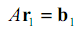
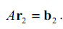
This equality is true for error-free measurements. Also the attitude matrix is not uniquely determined if either the pair and or and are parallel or anti parallel.
If we have an orthogonal right-handed triad of vectors { ,,} in the reference frame, and a corresponding triad { ,,} in the spacecraft body frame, the attitude matrix,
will transform the to the by
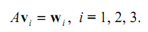
The TRIAD algorithm forms the triad { ,,} fromand , and the triad { ,,} from and The triads can be formed in three convenient ways. First, it is useful to define the normalized cross products
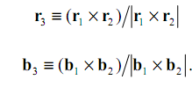
Two of the TRIAD attitude estimates are
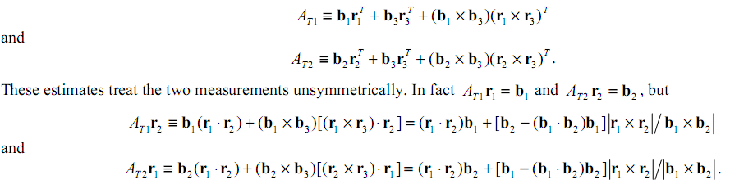
Thus the estimate emphasizes the first measurement and emphasizes the second.
Optimal attitude estimate
In the above equations and are weights of and respectively which helps us to give more or less emphasis to one of the estimates. These weights will depend on the accuracy of the instruments used. For eg, if the sun sensor used is more accurate then the magnetometer the weight factor will be chosen such that more emphasis is given to the reading from sun sensor.
If
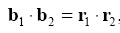
the optimal estimate is
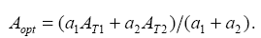

DIRECT QUATERNION METHOD
All the methods considered so far compute the attitude matrix. If a quaternion is desired, it can be extracted from the attitude matrix. A quaternion q has vector part q and a scalar part qs, which we write as
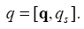
A unit quaternion can be used to represent an attitude matrix, which rotates a vector by
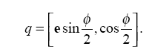
The derivation of the direct quaternion method begins with the observation that the quaternion that maps the reference vector r1 into the body frame vector b1, using the minimum-angle rotation, is
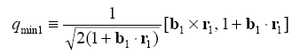
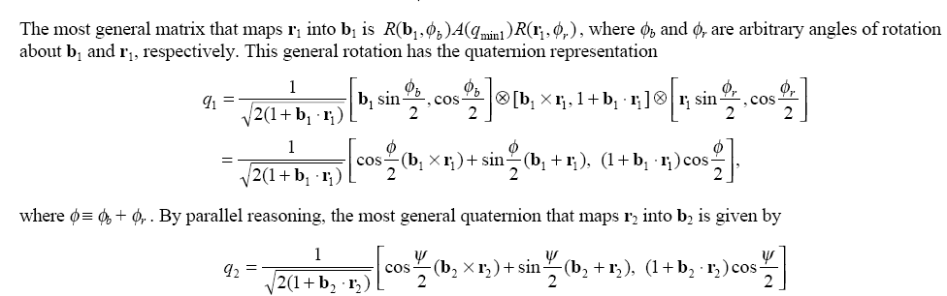
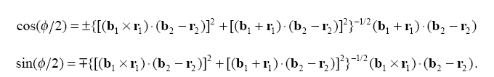

So we get,
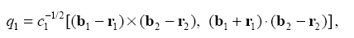
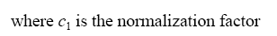
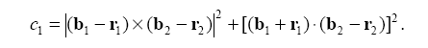
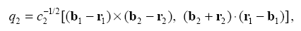
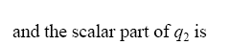
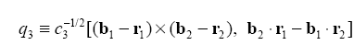

The above equations have been simulated in MATLAB.

3. COMPONENTS OF ADCS

- Sensors- To determine the orientation and position of the satellite.
- Algorithms-To calculate the deviation from the desired orientation and to generate actuation command to counter the deviation
- Actuators-To act upon the signals given by the control algorithms and to produce the necessary torques

BLOCK DIAGRAM SPECIFYING BASIC MODE OF OPERATION

3.1 SENSORS

To determine the attitude of the satellite and decide via the controller how to actuate the satellite for it to point at the desired angle, we need to have sensors.

3.2 ALGORITHMS

- Deterministic Attitude Determination Algorithm
- Kalman Filtering Algorithm
- Control Algorithm
- Magnetic Field Model
- Sun Model
- Orbit Model
- Albedo Correction Algorithm

3.3 ACTUATORS
The Actuators of the ADCS are the components that will change the orientation of the satellite. Various kinds of actuators can be used. Our choice of actuators will depend on the constraints of the sub system. Details are given in section 7.

4. MAGNETOMETERS

• Primary sensors for attitude determination.
• Perform all applications that gyroscopes perform
• Magnetometer finalized: HMR2300

4.1 Process of selection

Comparison of different magnetometers:
HMC1001, HMC1002, HMC1022 Magnetic Sensors:-
These are 1 and 2 axis magnetometers which are difficult to implement. Power consumption is greater and resolution is less than 3 axis magnetometers.

HMC1053 Three-Axis Magnetic Sensor:-
This is a high-performance magneto resistive sensor design.
Advantages:
Magneto resistive chips positioned for orthogonal three-axis sensing, miniature size and low height profile in a surface mount package.

HMR v/s HMC: HMC chips need to be put on PCBs whereas the HMR are entire systems. Hence flexibility is lost. But they can be more reliable.

HMR 2003- 3 axis magnetic sensor:
Its output is in analog form but our requirement is digital output.

HMR2300- digital magnetometer:
This is the magnetometer chosen for TUSSAT.
It has a better resolution and accuracy as compared to all.
GENERAL DESCRIPTION

The Honeywell HMR2300 is a three axis smart digital magnetometer to detect the strength and direction of the incident magnetic field. The three of Honeywell’s magneto resistive sensors are oriented in orthogonal directions to measure the X, Y and Z vector components of a magnetic field.

These sensor outputs are converted to 16 bit digital values using an internal delta sigma A/D converter. An onboard EEPROM stores the magnetometer’s configuration for consistent operation. The data output is serial full duplex RS 232 or half duplex RS 485 with 9600 or 19,200 baud rates.

- SUN SENSORS

Satellite attitude determination is usually made using one large body in space as a reference. The sun and the earth are the most used. But sun sensors are more accurate, and hence are more widely used. A Sun sensor uses the sun as a reference to determine the orientation of the satellite in the orbit.
There are two principal kinds of sun sensors, analog and digital. Digital sensors are more accurate and versatile, but also more expensive. Analog sun sensors can provide sufficient accuracy for many specific tasks.
ANALOG SENSORS
Analog sun sensors, also called cosine sun detectors, are based on silicon solar cells whose output current is proportional to the cosine of the incident sun angle and on additional physical properties pertinent to the specific cell.
One-Axis Sensors
A single solar cell is not by itself very useful, because it measures the angle of the sun's incident rays without identifying their direction. Two cosine detectors are necessary to measure the incidence angle of the sun in a defined plane in the satellite, thus achieving a one-axis sun measurement.
The simplest possible arrangement is shown below:

It consists of two photocells whose axes are inclined by an angle relative to the sensor-head normal axis N. The sun rays are inclined relative to the normal N by the angle which is to be measured. With the mechanical arrangement shown in the figure, the sun rays deviate by from the normal to the CD2 surface, and by from the normal to the CDl surface. Thus the output current from CDl is proportional to; the output current from CD2 is proportional to .
If we subtract the two output currents, the first from the second, the difference will be:

For comparatively small sun inclinations, the output is nearly linearly proportional to . The percentage error for increasing sun inclination will be
The analog sun sensor described here has a very good accuracy at null inclination, but clearly the accuracy decreases with increasing alpha.
Two-Axis Sensors
In order to determine the three components of the sun vector in the body frame, two spatial angles must be measured and hence two single-axis sun sensors are necessary. The second sensor is oriented 90° with respect to the first. We define beta as the inclination of the sun vector in the second sensor; now the two measured angles alpha and beta provide the data necessary to determine the sun's vector orientation in the body axis frame. The two axis sensors can be formed by either integrating two single axis sensors or by using an optical head in which four photocells are located. Using a simple algorithm based on the sums and differences in individual currents of four photocell detectors, the equivalent currents proportional to the orientation of the sun vector about the Y_{s} and Z_{s} axes can be calculated.
TWO AXIS SUN DETECTOR

Characteristics and Specifications:
There are five important characteristics necessary to define an analog sun sensor.
(1) Field of view - the maximum deviation of the sun vector from the optical axis of the sensor that can be measured, or sensed. The sun-sensor FOV does not have to be a circular cone. Moreover, there can be different sensitivity ranges for the two directional planes in which the two orientations of the sun vector are measured.
(2) Linear range - the angular range in which the sensor output is linearly proportional to the angular deviation of the sun projection in the plane of measurement.
(3) Linearity error - the maximum deviation of any point from the best straight line through all points in the linear range of the sensor.
(4) Nominal scale factor - the maximum analog output value in the linear range divided by the total FOV in this range.
(5) Accuracy - the minimum unexpected error that cannot be foreseen and compensated.
DIGITAL SENSORS
The basic digital sun sensor is a single-axis device. Exactly as with their analog counterparts, two single-axis digital sensors are installed with their optical planes positioned 90° apart to obtain a two-axis digital sun sensor. It consists primarily of an optical head together with an electronics box in which the direction of the sun with reference to the head's axis frame is computed. The optical head is a slab, with index of refraction n, on whose upper side is a narrow entrance slit for the sun rays. On the lower side of the slab is located the reticle slit pattern, composed of a set of reticle slits laid out on that surface in an array that enables the sun orientation to be expressed in digital code form. In today's digital sun sensors, the Gray binary coded reticle pattern is the most commonly used. The Gray code is an equidistant code, which means that one and only one bit changes for each unit distance.
DIGITAL SUN SENSOR

As an example, the ‘Adcole’ two axis digital sun sensor has the following basic characteristics: field of view- 128° x 128° (each sensor) , least significant bit size- 0.5°; accuracy- ±0.25°
The outputs from the Gray code and fine bits are processed in the electronic box, which calculates the orientation of the sun in the sensor's axes frame.

COMPARISON BETWEEN ANALOG AND DIGITAL SENSORS
- A digital sensor consumes more power and is more massive than a typical analog sensor due to the need for additional circuitry to implement algorithms like centroiding.
- Average accuracies of analog sun sensors are approximately 0.2⁰, whereas digital sensors can produce accuracies on the order of 0:01⁰. Technologies like MEMS fabrication can help to reduce the size and power consumption of digital sun sensors.
- Also digital sun sensors need direct sunlight and so they must be installed at the sides of the satellite instead of several solar cells. In our case this is a critical problem because fewer solar cells means less power provided to the satellite.
We are still researching on which would be better for us.
Working of analog sun sensors:
They are composed of solar cells which work on phenomenon of ‘photoelectric effect’. The amount of power produced directly depends on:
- Intensity
- Frequency
Because the sun’s luminance and spectrum are well known, we can draw a function of the current and voltage produced by a single solar cell under various lightning conditions (figure 3.1).

Conclusion:
In voltage range of 0 to 2.5 V, as intensity (power per square meter) increases current increases. Hence the electrical model:
Current induced can be represented in terms of hit angle as

By measuring the current produced by 3 solar panels that share an apex, the suns vector (a unit vector directing on the sun), can be calculated.
The sun vector in 3D is therefore defined by:
Where X, Y and Z equal 1 or –1 depending on the solar panel’s location: on the positive or negative side of the satellite
DIGITAL SUN SENSORS
Principle of measurement and description of the optical part of a simple digital sun sensor:
The principle of a digital sun sensor is shown below. The sun is imaged on the surface of an image sensor through an array of apertures. And the centroids of these light spots are calculated by a following processing circuit. With these centroids, the incidence angle can be then calculated. There are n×n results if the structure of optical system is an n×n aperture-array. As the sun light can be treated as a parallel light, the average of these results is exported as the final incidence angle.
Suppose the incidence direction of sun light is V, the angle with x and y axes is α and β respectively, and the distance between aperture plane and image surface is H. If the centre coordinates of the i^{th} aperture are (X_{mi},Y_{mi}), and the corresponding light spot center coordinates are (X_{ci},Y_{ci}), the α
and β can be calculated by
PRINCIPLE OF DIGITAL SUN SENSOR

- CONTROL ALGORITHMS

6.1 KALMAN FILTER

Attitude determination algorithm:

The Kalman filter is a set of mathematical equations that provides an efficient computational (recursive) means to estimate the state of a process, in a way that minimizes the mean of squared error. The filter is very powerful in several aspects, it supports estimations of past, present and even future states, and it can also do so even when the precise nature of the modeled system is unknown.
The state of the system is represented as a vector of real numbers. At each time update, a linear operator is applied to the state, generating the new state with some noise added.

KALMAN FILTER:

Needed to link the information of the sensor to an estimation of the attitude. Only one sensor can be used but more redundancy and hence a better estimation with more no. of sensors.
KALMAN filter- minimizes mean of squared errors and thus is an OPTIMAL filter. Some other methods are available but they can lose the three-axis attitude estimation when two non collinear vectors are not available. There is no such problem with Kalman filter.

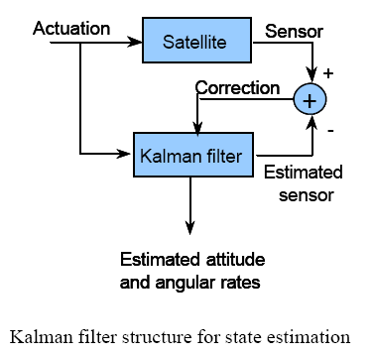

Underlying System Dynamic Model:

The Kalman filter model assumes that the true state at time k is evolved from the state at (k − 1) according to the equation:
Where, the n x n matrix A relates the state at the previous time step k-1 to the state at the current step k.
is the model noise
At time k an observation (or measurement) z_{k} of the true state x_{k} is made according to
H_{k} - the observation model which maps the true state space into the observed space
v_{k} - the observation noise

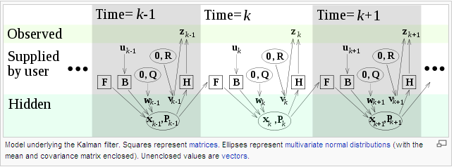

The Kalman filter is a recursive estimator. This means that only the estimated state from the previous time step and the current measurement are needed to compute the estimate for the current state. No history of observations and/or estimates is required.
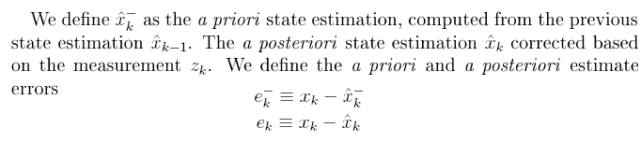
The Kalman filter has two distinct phases:
Predict and Update. The predict phase(also called time update) uses the state estimate from the previous timestep to produce an estimate of the state at the current timestep. In the update phase (also called measurement update or corrector equations), measurement information at the current timestep is used to refine this prediction to arrive at a new, (hopefully) more accurate state estimate, again for the current timestep.
The a priori state and covariance is obtained by the predict phase equations:
Predicted state | 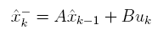
In form of covariances | 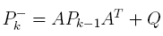

These two equations project forward in the future the state of the system and the covariance. The a posteriori state estimate and covariance is provided by the update phase equations:

UPDATE:
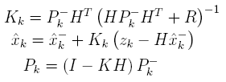
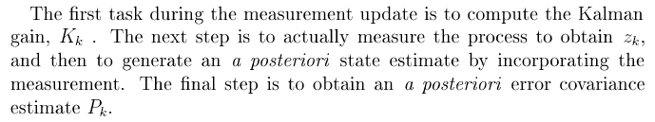
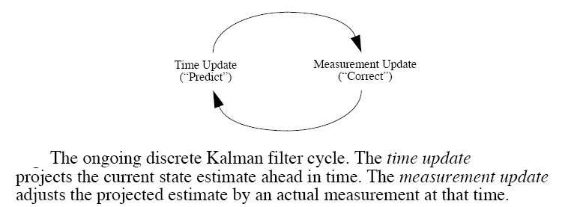

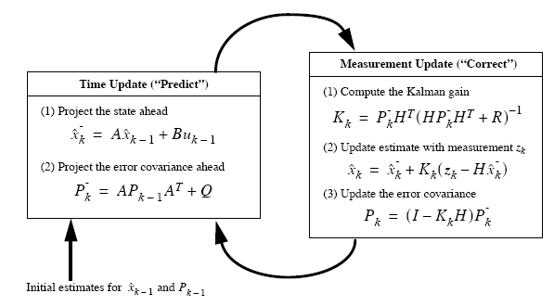

The attitude control system needs to operate in several circumstances. We divided these into separate tasks, so that the control methods can be more specifically applicable. The first task is to remove angular velocities after being launched out of the P-POD. These velocities are eliminated using "B-dot control" with the magnetorquers.

6.2 DETUMBLING CONTROLLER

The purpose of detumbling controller is to detumble the satellite after release from the launch vehicle and to ensure that the satellite remains controllable. In situations where control of the satellite has been lost, the controller must be able to regain control. This is done by reducing the kinetic energy of the satellite, thereby reducing the angular velocities to a level. Generally the detumbling controller is implemented only at the start that is after the launch but the mechanism is such that it is activated at a critical angular velocity. The attitude control system start dampening out the angular velocities of the satellites and there by regains control of satellite using B-dot control law.
B-Dot controller has been chosen and it is particularly well suited for the job, since it only requires the derivative of the magnetic field as input. Hence it is capable of working when all other orbital information is missing.
The aim of B-dot controller is to reduce the kinetic energy of the satellite.

Block Diagram:

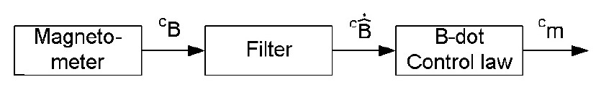
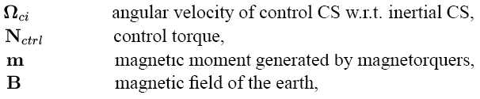

The detumbling controller generates a magnetic moment in a direction such that the kinetic energy of the satellite is dissipated.
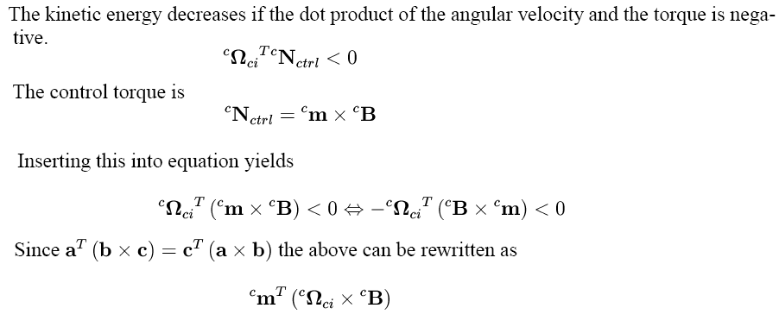
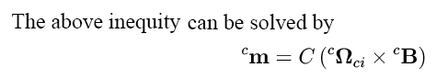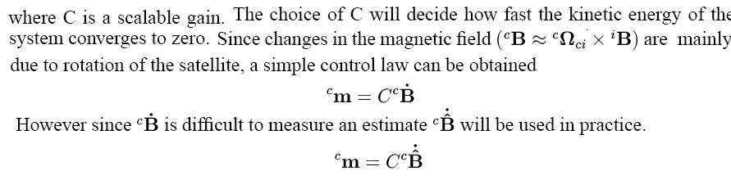

6.3 ALBEDO CORRECTION ALGORITHM
- Earth albedo is an expression for the reflectivity of Sun light by the Earth surface
- It is varying.
- The Earth albedo is approximately 35% of the sun light intensity.
- The average value of the Earth albedo is 30% +,-5% of direct solar flux.

Albedo Correction
- Earth albedo is added in the sun model by adding a nadir-vector to the sun vector with a length of 30% of the sun vector.
- The nadir vector is found using the on-board orbit model.
- The angular errors between the vectors are reduced.

6.5 REFERENCE MODELS

In addition to the vector measurements made with sensors in the SCB frame, reference models are used for determining additional vectors in the ECI frame. They are needed for magnetic field and determining a direction to the Sun. In addition an orbit model is needed a position in orbit for the magnetic field model.

The reference models we are using:
Magnetic field model
Sun Model
Orbit Model

Orbit model: The orbit model determines the position of the satellite based on Julian date.

Magnetic field model: the magnetic field vector in the ECI frame is determined based on the satellite position.

Sun model: This model determines the direction vector to the sun in the ECI frame based on Julian date.

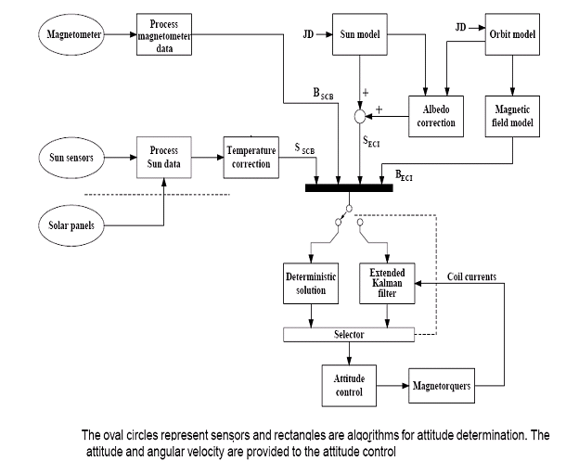

ORBIT MODEL

Satellite orbits lie in planes that bisect the orbited body. If the Earth were not rotating, each orbiting satellite would pass over the same point on the Earth with each orbit, crossing the equator repeatedly at the same longitude. Because the Earth is constantly rotating, each orbital pass of the satellite, appears to be to the west of the previous one. In reality, the Earth is rotating eastward as the orbital plane remains fixed.

ORBIT SELECTION CRITERIA:
We are assuming our orbit to be 9:30 AM –PM sun synchronous orbit with altitude of 700 km to 800 km which is to be launched in 1st quarter 0f 2011. All our current calculations are using are using this orbit. None of the functions of the satellite are heavily depended on the orbit.
Re=6378.137 km
a =700 km+ 6378.137 km=7078.137 km to 7178.137 km
Using an online calculator the values obtained:
Satellite orbit velocity=7.51Km/s
g = m/s² = x g on the earth's surface.
v =m/s=km/h=mi/h.
The period of the orbit is minutes = hours.
CALCULATIONS (ASSUMING ORBIT TO BE CIRCULAR (e=0)):
Since orbit is sun synchronous-

Where-

J2 is the perturbation due to oblateness of earth: 1.08e-3

ω _{p} is the period of revolution of earth around sun : 1.991e-7

Using orbital velocity from above ie 7507.255266634942 m/s

Ω=v/r where r=7078.137 *10³ m
ωsat is the angular velocity of satellite around earth : 1.060625877e-3

i is the inclination

Substituting values we get, i=98.204⁰
Since our orbit is circular therefore-
ω=0 Argument of perigee

At vernal equinox if sun passes overhead at a particular place on equator at noon then the point on equator corresponding to 9:30 am will be separated by
Ω=(12-9.5)*15=37.5⁰
Therefore, Ω=37.5⁰
True anomaly (ν)=Eccentric Anomaly=Mean Anomaly=0 (Depends upon time since launch) Therefore six orbital parameters are-
a | 7078137 m
e | 0 (Assumed)
i | 98.204⁰
Ω | 37.5⁰
ω | 0
Ν | - (NA)
TIME PERIOD: | _{5925.94851 s=98.7658 min}

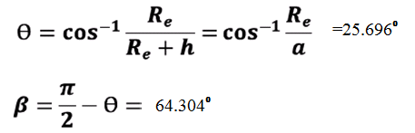
COMMUNICATION TIME:
Max time available= time above horizon= =14.099 min

ANGLE FROM ZENITH:

Therefore angle of zenith =71.625899⁰

Therefore effective communication time=1.48 min
2.5277*10¹³ m²

GROUND TRACK:
- T_{p} = 98.7658 min which is not an integral multiple of 1 day therefore
- α=Angle by which earth rotates in T_{p} time=24.69⁰
In 24hrs i.e. 24*60 min=360⁰
So in 98.7658 min=24.69⁰
- No. of revolutions per day=14.5799
In one revolution ground track moves westward by
- Therefore in 14 revs angle travelled =345.66⁰
- In 15 revs angle =370.35⁰

REVISIT TIME:
- Since time period is not an integral of 1 day therefore revisit time is not one day. However after 14 revs satellite is 14.34⁰ from station and since
Θ= 25.696⁰, therefore is visible from station. Similarly after 15 revolutions satellite is 370.35⁰ from ground station and therefore is again visible.

If we do not consider the orbit to be circular:
Terminology:
i: The inclination is an angle from 0 to π. It is the angle of the orbit plane compared to the fixed equatorial reference plane.
Ω: The longitude of the ascending node is an angle that takes values from 0 to 2π: It is the angle from the axis X_{ECI} to the ascending intersection of the reference and orbital plane. X_{ECI} is taken as the unit vector in the direction of the first point in Aries, which incidentally is the line common to both the earth’s equatorial plane and ecliptic planes.
ω: The argument of perigee is an angle taking values from 0 to 2π. It is the angle from the longitude of the ascending node to the perigee, which is the point of the orbit where the satellite is closest to the Earth.
f: The true anomaly is the angle taking values from 0 to 2π, which measures the angle between the perigee and the radius vector from the Earth to the satellite’s current position.
Kepler’s Law:
If T is the orbital period and Δt is the the time it takes the satellite to get from the perigee located at point P,to its current position at point C , then Kepler’s Law may be stated as
Δt/T = Area of sector FCP/Area of Ellipse (0)

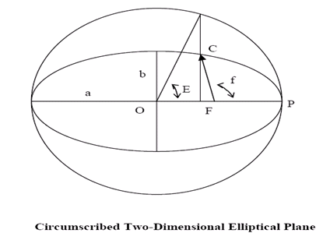
The following results have been derived:
Area of sector FCP = (1/2) ab (E − e sinE) (1)
Area of an ellipse = πab (2)
(3)
The parameter μ is the gravitational constant that has the value of 398,600 km³/s² for the Earth, b is the semi minor axis of the ellipse, and E is the eccentric anomaly.
It should be noted that it is quite easy to convert between E and f using the following equation:
Combining equation (0) and (3):
Orbit Propagation Algorithm:
Inputs: Initial time, t₀; desired time, t_{d}; either the radius and velocity at the initial time, or the orbital elements, including f₀, the initial true anomaly.
Step 1. If the initial known parameters are the position and velocity of the satellite, convert them to the orbital elements.
CONVERSION:
Given the radius and velocity vectors in the Geocentric Celestial Inertial coordinate system, r and v, the first step in finding the orbital elements lies in obtaining the vector h, which is defined as:
h = r × v
The parameter h is a constant vector for all position and velocity vectors in a given orbit, and defines the orbit plane. Next, the nodal vector is defined as:
Where the vector Z_{ECI} is typically chosen to be the line passing through the Earth’s centre and the North Pole.
The nodal vector n defines the ascending intersection of the reference plane and the orbital plane.
Once these two parameters have been defined, it is possible to directly solve for the orbital elements through the following equations:

Step 2. Convert f₀ to E₀, the eccentric anomaly at the initial time using:
.
Step 3. Find Δt_{o}. This represents the time that has passed since the satellite was last at perigee:
Step 4. Let t_{p} =t₀ − Δt₀ . This is the time when the satellite was last at perigee.

Step 5. Let Δt_{d} = t_{d} − t_{p} This is the time that passed from the perigee time to the desired time, where t_{d} is desired time.
Step 6. Using Δt_{d}, solve for Ed. This is the eccentric anomaly at the desired time.
Step 7. Convert E_{d} to f_{d} using Equation (47). This is the true anomaly at the desired time.

Step 8. If necessary, convert the orbital elements to the desired position and velocity vector
DETAILS:
The radius vector r in the inertial reference frame may be found by the following equation:

IGRF MODEL

The attitude estimator requires a reference magnetic field vector to compare the information provided by the magnetometer. The geomagnetic field is a naturally occurring phenomenon, which has been measured at a variety of positions on the Earth’s surface. Due to constraints of storage space on board the satellite computer, storing large amount data for expected magnetic field values is not feasible. Instead, the reference magnetic field value is estimated by using International Geomagnetic Reference Field (IGRF) standard, mathematical model. The IGRF is a global model of the geomagnetic field. It allows spot values of the geomagnetic field vector to be calculated anywhere from the Earth's core out into space. The IGRF is generally revised every five years by a group of modellers associated with the International Association of Geomagnetism and Aeronomy (IAGA). The reference value obtained is defined in the Earth Centered Earth Fixed (ECEF) reference frame.

The IGRF model comprises a set of spherical harmonic coefficients called Gauss coefficients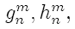in a truncated series expansion of a geomagnetic potential function of internal origin :
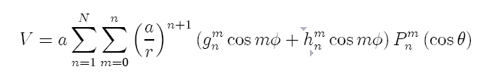
where a is the mean radius of the Earth (6371.2 km), and r, φ, θ are the geocentric spherical coordinates. r is the distance from the centre of the Earth, φ is the longitude eastward from Greenwich, and θ is the colatitude equal 90◦ minus the latitude(which we’ll get from the orbit model) .The P_{n}^{m} (cos θ) are Schmidt quasi-normalized associated Legendre functions of degree n and order m, where n ≥ 1 and m ≤ n. The maximum spherical harmonic degree of the expansion is N.
The model is a collection of MATLAB functions that calculate a `magnetic field vector when the field is regarded as a gradient of a potential function that, in turn, can be described as an infinite series of spherical harmonics. Computation of the field vector is performed speedily by means of recursion formulae.
The p(n.m) can be obtained from the following recursion relations:
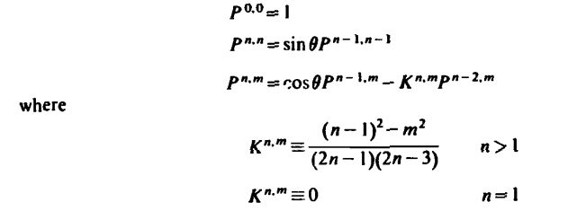

Because the gradient in Eq. (H-I) will lead to partial derivatives of the p(n.m) we need
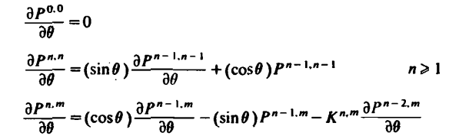
Also note that
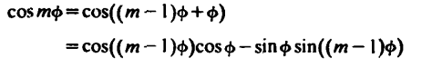
A similar recursion relation can be derived for sinmϕ.
Given the coefficients g(n.m) and h(n.m) and above recursion relations the field B is calculated from the following Eqs. Specifically.
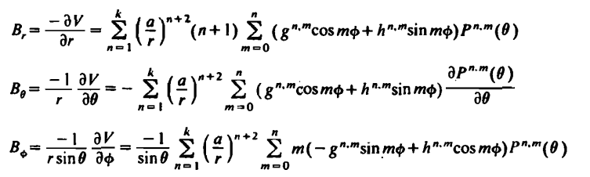

Here, B, is the radial component (outward positive) of the field, B, is the coelevation component (South positive), and B. is the azimuthal component (East positive).The geocentric inertial components used in satellite work are

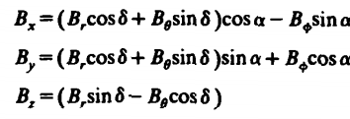
Note that B is still a function of longitude, ϕ, which is related to the right ascension, a, by:
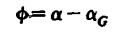
where α_{G} is the right ascension of the Greenwich meridian or the sidereal time at Greenwich.

APPLICATION:

The measurements from the magnetometer are compared with the modelled magnetic field. As the magnetometer gives an output in the body frame, and the model is in the orbit frame the relationship between these frames can be used to calculate the attitude of the satellite. This gives the roll, pitch and yaw angle.
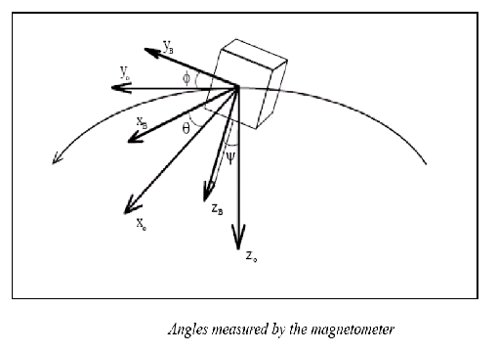
SUN MODEL
- Basic concept

The sun model on-board the satellite is used to determine the direction to the Sun in the ECI frame for the attitude determination. Though, it is in fact the Earth which orbits around the Sun, in the Earth Centered Inertial (ECI) frame, the Sun will be changing position while the Earth is centered in Origo For the determination of the satellites attitude with sun sensor a knowledge about the direction to the Sun In the ECI frame is required. This is obtained by the use of an on-board Sun model which calculates the direction to the Sun based on the current time given as Julian date.

2) Parameters involved
(These parameters form the basis of satellite orbital determination. Hence need to be understood thoroughly.)

Two Line Elements
An option to determine a satellites motion after its launch is to use Two Line Elements (TLE), also called NORAD lines.
These information’s are based on, that every object, which orbits the earth and is bigger than a tennis ball, is
Monitored and tracked by Radar by NORAD (North American Aerospace Defense Command). The format has been used since the beginning of space flight and is still in use by NORAD and NASA. The origin of the Two Line Elements is unknown but some reports refer to it as T-card format.

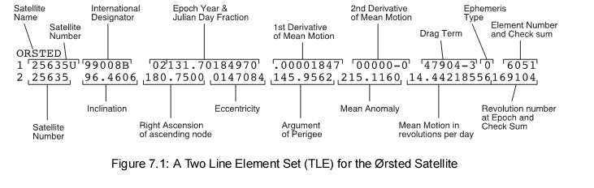

The Two Line Elements consists of two 69 character strings of data in a format as shown in above figure.

The parameters are:
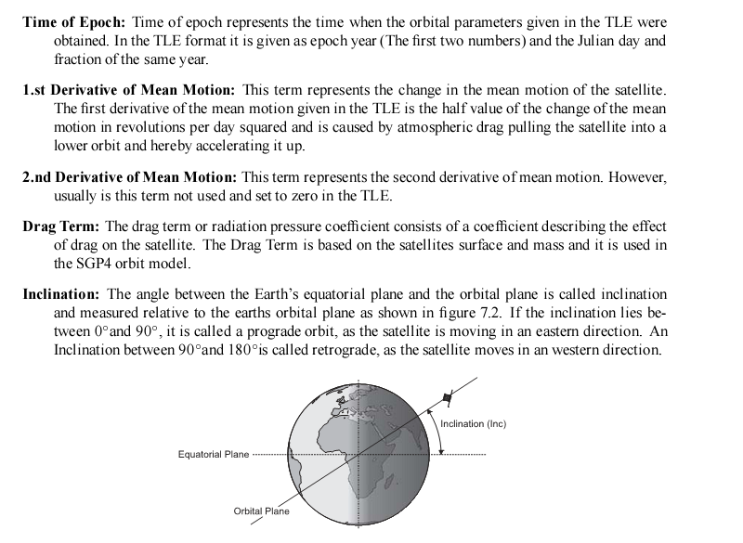
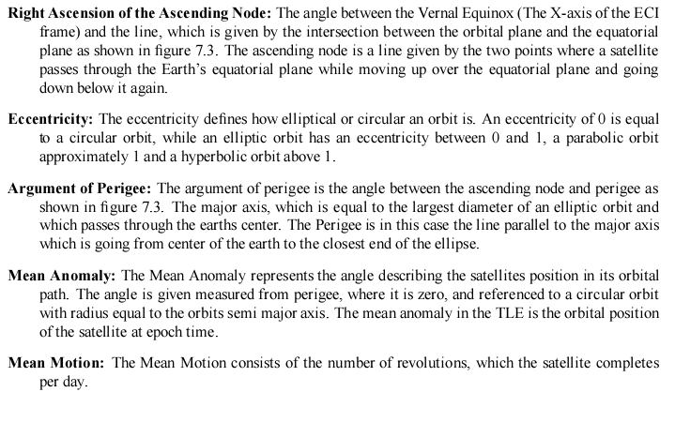

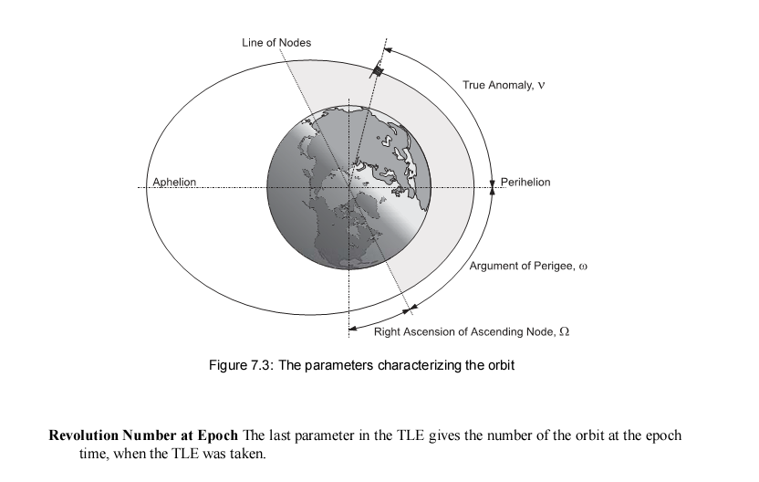

JULIAN DATE
The Julian date (JD) is the interval of time in days and fractions of a day since January 1, 4713 BC Greenwich noon, Julian prolepsis calendar.^{[1]} In precise work, the timescale, e.g., Terrestrial Time (TT) or Universal Time (UT) should be specified.^{[2]} The Julian day number (JDN) ^{[3]} is the integral part of the Julian date (JD).^{[4]} Negative values can also be used, although those predate all recorded history. Now, at 10:31, Monday October 12, 2009 (UTC) the Julian day number is 2455116.A Julian date of 2454115.05486 means that the date and Universal Time is Sunday January 14, 2007 at 13:18:59.9.The decimal parts of a Julian date:
0.1 = 2.4 hours or 144 minutes or 8640 seconds
0.01 = 0.24 hours or 14.4 minutes or 864 seconds
0.001 = 0.024 hours or 1.44 minutes or 86.4 seconds
0.0001 = 0.0024 hours or 0.144 minutes or 8.64 seconds
0.00001 = 0.00024 hours or 0.0144 minutes or 0.864 seconds
A very common time format dealing with the astronomical calculations and satellite orbit propagations is the Julian dates. It is counted in days plus a fraction of the day, which begins at noon universal time. The Julian Date is counted in days since the 1st of January 4713 BC at noon universal time.
3) Parameters calculation
A) epoch mean anomaly.
The first step is to determine the current mean anomaly of the satellites orbital position. This is achieved by using the time since epoch, which is the current time in Julian Date minus the Julian Date at Epoch, which is given in the TLE.
The current epoch mean anomaly of sun is calculated as follows where mean motion of sun (n) is known:
b) The position of the Sun in the ECI frame in orbital plane (the ecliptic longitude).
To calculate the ecliptic longitude of the Sun most of the parameters, which characterize the orbital motion of the Sun, are already inserted into the equation. Due to this the only input needed is the Julian Date and the current Mean Anomaly of the Sun given in previous equation.
c) Obliquity of ecliptic plane: In our solar system, the Earth's orbital plane is known as the ecliptic, and so the Earth's axial tilt is officially called the obliquity of the ecliptic. In formulae it is abbreviated with the Greek letter ε.
The Earth currently has an axial tilt of about 23.44°.[
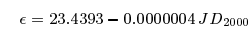
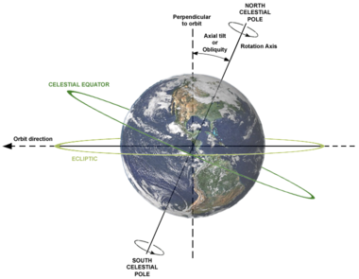

The position of the Sun is determined as a unit vector in the ECI frame. This is done in equation 8.4 by into Cartesian coordinates by including the obliquity transforming the ecliptic longitude of the Sun Of the ecliptic plane.
This is the final direction vector needed to obtain the sun position in ECI frame.
The Simulation of Sun Sensor Signals:
The output of the sun model as reference in the simulation is also used to generate simulated input signals on the sun sensors of the Cubesat. The sun sensors are mounted on each side of the Cubesat referring to a positive and negative direction on the axes of the SCB frame. Accordingly the simulation of suns sensor signals is simply archived by rotating the sun direction vector into the SCB frame and applying signal on each sensor which is pointing in the same direction. This is done by taking the angle between the normal vector of each sun sensor and the sun vector into account. Sun sensors pointing in the opposite direction are kept blank.

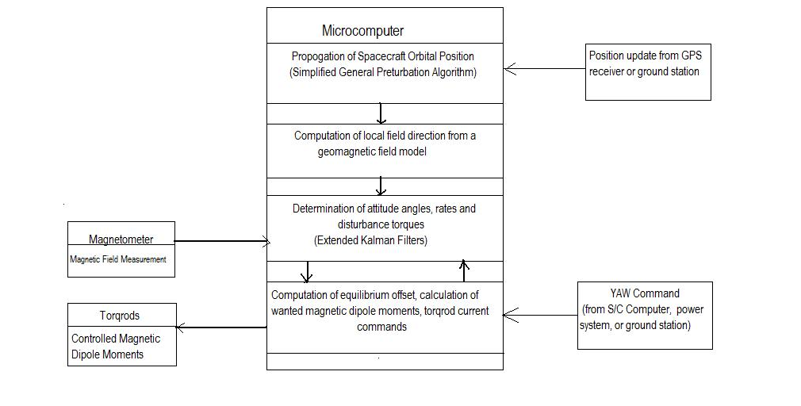
FLOWCHART

- ACTUATORS

The actuators that can be used are:
1.Momentum wheel
2.Firing thrusters
3.Magneto-torquers.

Rejection of different attitude control methods:
- The Spin stabilization methods use the whole body of the satellite as a gyroscope. We did not go into the details of this system because this makes the system very complicated and uses a lot of space inside the body of the satellite.
• The principal of working for the momentum wheel and the thrusters is the conservation of momentum. The limitations for the first two systems i.e. momentum wheel and the thrusters is that of complexity and size respectively.
• Thrusters also have a limitation that they require fuel for functioning. Thrusters have additional limitation that they are subject to engine wear of repeated cycle usage.
Due to these reasons thrusters are not a preferred solution.
- Magnetotorquers use the principal of a solenoid experiencing torque in an external magnetic field.

7.1 MOMENTUM WHEELS (REACTION WHEELS)

Momentum wheels work on the principle of conservation of angular momentum. This does not use any type of fuel and therefore has evident advantages over thrusters. Reaction wheels are usually implemented as special electric motors. Both spin-up and braking are controlled electronically by computer controls. The strength of the materials of a reaction wheel determines the speed at which the wheel would come apart, and therefore how much angular momentum it can store.
Since the reaction wheel is a small fraction of the spacecraft's total mass, easily-measurable changes in its speed provide very precise changes in angle. It therefore permits very precise changes in a spacecraft's attitude and orientation.
Disadvantage:
Over time reaction wheels may build up stored momentum that needs to be cancelled. It is due to this reason that momentum wheels are supplemented with other attitude control mechanisms. In the presence of a magnetic field (as in low Earth orbit), a spacecraft can employ magnetorquers (better known as torque rods) to transfer angular momentum to the Earth through its magnetic field.

  - MAGNETIC-TORQUERS

- Magnetorquers utilize the earth’s magnetic field to de-tumble the satellite.
- This is done by placing three symmetrically looped conducting coils along three perpendicular faces of the satellite.

The design of the magnetorquers is based on the assumption that all three coils have same properties. This means that the mass of each coil is equal to one third of the total mass. The coils will be positioned inside the satellite body, connected via omega clamps to meet the requirements of orthogonality as shown:

The magnetorquers are essentially induction coils which are used to create a magnetic field. This induced magnetic field interacting with the earth’s magnetic field create a torque which is then used to change the attitude of the system. The torque produced is proportional to earth’s magnetic field and hence are less effective at higher orbits.
Torquers can be either in form of rod or coil. Rod configuration is the configuration that uses wire wrapped around a long ferromagnetic material. This configuration greatly increases the weight. Hence the configuration chosen is coil configuration.
For our TUSSAT three magnetorquers have been chosen as actuators. Using 3 momentum wheels have been ruled out because the weight and space needed by these does not meet our requirements.
This method has one major flaw that it depends on the cross product between the vector normal of the coil area and the magnetic field strength vector. So if both the vectors are aligned the produced torque is null. In every time instant there will be one direction of the TUSSAT, the one parallel to the magnetic field, where the magnetic torques will not be able to produce a torque. So a secondary actuator which does not depend on the direction of the magnetic field is needed. Using one momentum wheel for this purpose is being considered as an option. The extra weight seems to be a compromise for the accuracy. As for this purpose we are still looking into the possibility of using a motor wheel that would basically be a stepper motor and would be used only along one of the three axis of the ORF.

7.2.1 Detailed analysis of chosen actuator

MAGNETOTORQUERS:
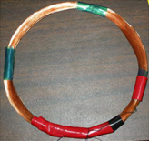

The working of magnetorquers is based on the well known fact that running a current through a wire loop generates a magnetic field and further magnetic fields interact to generate torque. The coil configuration is chosen. A current flowing through the torque coils generate a magnetic dipole moment according to the following equation:

(1)
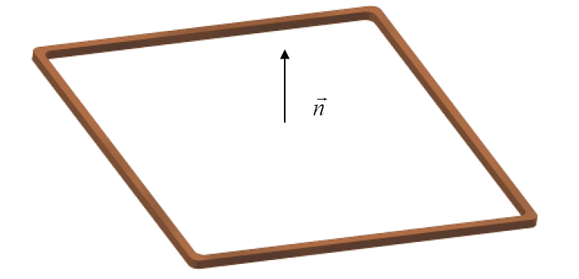

m is the magnetic moment of the coil
N is the number of turns of coil
I is the current flowing through the coil
A is the cross sectional area of the coil

There are multiple magnetorquers: one for each direction, so we define a vector of magnetic moments m= [m_{x}, m_{y}, m_{z}] with [m_{x},m_{y},m_{z}] being the magnetic moments associated with the magnetic torquers on x, y, z faces respectively.

The direction of the dipole moment is normal to the coil, and is determined by the right hand rule according to the direction the current is moving in the coil.

The torque produced by the magnetic torque is the cross product of the magnetic field strength (T), with the magnetic moment of magnetorquers:

(2)
As can be seen from the figures below the torque generated tends to align the magnetic dipole moment with the geomagnetic field. Note that there is no generated torque if the magnetic dipole moment is already aligned with the geomagnetic field.

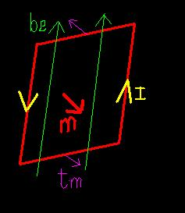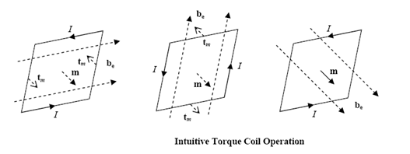

Sizing of Magnetic Coils:
There are in general two criteria that determine sizing of the coils:
1) The physical constraints
2) The disturbance torques (The magnetorquers must under the worst conditions be able to counter act the largest possible disturbance torque)
The generated torque is proportional to the area of the coil. So the coils should be as large as possible. But the satellite size and other components limit the area of coils. Another constraint limiting the no. of turns in the coil is the power availability.
The total power dissipated by the coil is given as:
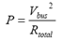
An H bridge will be used at the input of torque that will be discussed later.
The total resistance is combination of coil and the H bridge:
The resistance of coil is:
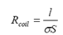
σ is the conductivity
l is the length of the wire and
S is the cross sectional area of the wire
The length of the coil is related to the dimensions as:

Where a and b are length and breadth of the rectangle (or the smallest triangle that encloses the coil if in round shape as shown in a previous figure) respectively.

Combining all the above equations we can easily find the no of turns as:
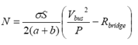

    - Materials for Coil
Basically there are two main materials which can be used as the magnetic coil.
1. Copper
2. Aluminum
The following factors are taken into consideration while selecting a magnetic coil
1. The resistivity of the material(ρ)
2. The material density(σ)
3. The temperature co-efficient(α)
4. The ductility of the material
The table given below has given the comparison chart between the copper and aluminum for the properties stated above:

As the producible magnetic moment is inversely proportional to the square root of product of the resistivity and material density, hence from the table given above aluminum is suited.

The rotation of the satellite will be mainly controlled by the square aluminum coils. These alumininum coils will stick to the walls of the Tussat and will continuously experience a magnetic field.
The size of the magneto torquers is basically the whole of the inside of satellite because all the walls are going to be basically lined with wires through which current will flow and will these will be responsible for the production of magnetic field around the satellite.

    - H bridge

The controller on the CubeSat requires that the magnetic field generated by the coils has to be both positive and negative. Thereby the current that has to run through the coils has to be both positive and negative. Since there is only a positive dc voltage available, the coils will be driven by a H-bridge in order to make both positive and negative currents through the coils.

The h bridge on which we are working upon is ZHB6790.
L293D has been rejected due to higher voltage requirements.

The H-bridge works by either turning on the Q1 and Q3 transistor to generate a positive current or by turning on the Q2 and Q4 transistor to generate a negative current. The coil
is connected between C1,C2 and C3,C4 on the H-bridge.

Diodes are placed at C1, C2 and C3, C4 on the H-bridge to either Vcc or Gnd, in order to remove peak voltage from the coils. The peak voltage will pass through the H-bridge thereby damaging
it if the diodes were not placed on the H-bridge. The h-bridge will be destroyed if the spark voltage is applied for longer periods of time.
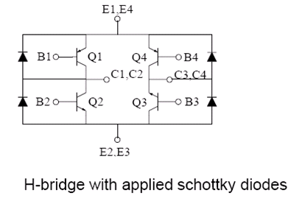
- The controllability of the satellite depends very much on the magnetic field generated by the coils.
- The magnetic field is linearly dependent on the current passing through the coils and the current is linearly dependent on the temperature of the coils.
- It is therefore necessary to either measure the temperature or the current. The temperature of the coils is not accessible in the satellite but the current is.
- It has been chosen to measure the current passing through the coils. The current is measured by applying small resistors in series with the coils.

7.2.4 Proposed Design of coils

  - First a suitable frame for winding the coils needs to be constructed.
  - The torque coils are bounded together with epoxy adhesive.
  - Before the manufacture of a coil could start the frame has to be treated with a special slip coat, that would prevent the epoxy from sticking to it.
  - The slip coat is to be applied at least five times with 10 min drying time in between. When the last coat has been applied, the slip coat needs around 30 min to cure before the frame can be used.
  - However if cured for longer or at higher temperature the slip coat would last for several releases, the slip coat can then be reused 2-3 times.
  - Before the first turn of the coil has to be wound, a coat of epoxy need to be applied to the bottom of the frame with a small brush.
  - When a layer is complete, a new coat of epoxy is applied.
  - This process is repeated until the desired number of turns was reached. A final coat of epoxy is then applied to the topside of the final layer.
  - The Al strips are then detached carefully in order to procure the coil. Three such torque coils are prepared.

